Word Equations  outcome = explanatory + other stuff  Y = X + other stuff | Summary Tables  # compute five-number summary  favstats(~ Y, data = data_set)  # create frequency table  tally(data_set$Y)  tally(~ Y, data = data_set)  # tally by condition  tally(~ Y < 1900, data = data_set)  # two-way frequency table  tally(Y ~ X, data = data_set, margin = TRUE, format = “proportion”) |  |  | Simple Statistics  mean(data_set$Y)  var(data_set$Y)  sd(data_set$Y)  cohensD(Y ~ X, data = data_set)  cor(Y ~ X, data = data_set)  b1(Y ~ X, data = data_set)  b1(my_model)  pre(Y ~ X, data = data_set)  f(Y ~ X, data = data_set)

Basics
print("Hello world!")

# assign value to object
my_number <- 5

# combine values into vector
my_vector <- c(1, 2, 3)

# first element in vector
my_vector[1]

# orders values or cases
sort(my_vector)

# arithmetic operations
sum(1, 2, 100), +, -, *, /
sqrt(157)
abs(data_set$Y)

# logical operations
>, <, >=, <=, ==, !=, |, &

# results in a new variable with values
# of TRUE or FALSE

data_set$C <- data_set$A > data_set$B
 | Data Frame  # structure of data frame  str(data_set)  # view first/last six rows  head(data_set)  tail(data_set)  # select multiple variables  select(data_set, Y1, Y2)  # first six rows of selected variables  head(select(data_set, Y1, Y2))  # select variable (a column)  data_set$Y  # find rows that meet some condition  data_set[data_set$Y > 40]  filter(data_set, Y > 300)  # find rows that do not have NA  filter(data_set, is.na(Y) == FALSE)  filter(data_set, !is.na(Y)) |  |  | # arrange rows by variable  arrange(data_set, Y)  # creates data frame from csv file  data_set <- read.csv("file_name", header = TRUE)  # convert quantitative variable  # to categorical  factor(data_set$Y)  factor(data_set$Y,  levels = c(1,2),  labels = c("A", "B"))  # transform values  recode(data_set$Y, "0" = 0, "1" = 50, "2" = 100)  # creates two equal sized groups  ntile(data_set$Y, 2)  # convert categorical variable  # to quantitative  as.numeric(data_set$Y)
Probability Distribution
# calculate the probability area
xpnorm(65.1, data_set$mean, data_set$sd)

zscore(data_set$Y)

# returns t at this probability
qt(.975, df = 999)
# returns F at this probability
qf(.95, df1 = 1, df2 = 100)

# CI using t distribution

confint(empty_model)

# calculate p-value using F-distribution
xpf(sample_f, df1 = 2 , df2 = 10)
Simulation  # sample without replacement  sample(data_set, 6)  # sample with replacement  resample(data_set, 10)  do(3) * resample (data_set, 10)  # mixes up values in a variable  shuffle(data_set$Y)  # simulate sampling 10000 Ys  # from normal distribution  sim_Y <- rnorm(10000, Y_stats$mean, Y_stats$sd)  # put simulated Ys into dataframe  data_set<- data.frame(sim_Y)  # simulate  # sampling distribution of means  sdom_sim <- do(10000) * mean(rnorm(157, Y_stats$mean, Y_stats$sd))  # bootstrap  # sampling distribution of means  sdom_boot <- do(10000) * mean(resample(data_set$Y, 157)) | # randomize sampling distribution of b1s,  # centered on 0  sdob1 <- do(1000) *  b1(shuffle(Y) ~ X, data = data_set)  # bootstrap sampling distribution of b1s,  # centered on sample b1  sdob1_boot <- do(1000) *  b1(Y ~ X, data = resample(data_set))  # count the number of b1s at the upper  # and lower extreme  tally(sdob1$b1 > sample_b1 |  sdob1$b1 < -sample_b1)  # return TRUE for middle 95% of distribution  middle(sdob1$b1, .95)  # randomize sampling distribution of PREs  sdopre <- do(1000) * pre(shuffle(Y) ~ X,  data = data_set)  # randomize sampling distribution of Fs  sdof <- do(1000) *  f(shuffle(Y) ~ X, data = data_set)  # counts extreme Fs  sample_f <- f(shuffle(Y) ~ X, data = data_set)  tally(~f > sample_f, data = sdof) |  | Fitting and Evaluating Models  # empty model  empty_model <- lm(Y ~ NULL, data = data_set)  # use one explanatory variable  my_model <- lm(Y ~ X, data = data_set)  # model predictions and residuals  data_set$empty_predict <- predict(empty_model)  data_set$empty_resid <- resid(empty_model)  # produce ANOVA table  anova(empty_model)  supernova(my_model)  # t-test, using pooled variance  t.test(Tip ~ Condition, data = data_set, var.equal=TRUE)  # pairwise comparison  # corrections: "Tukey","Bonferroni","none" pairwise(my_model, correction = "Tukey")
Visualizations  gf_point(Y ~ X, data = data_set)  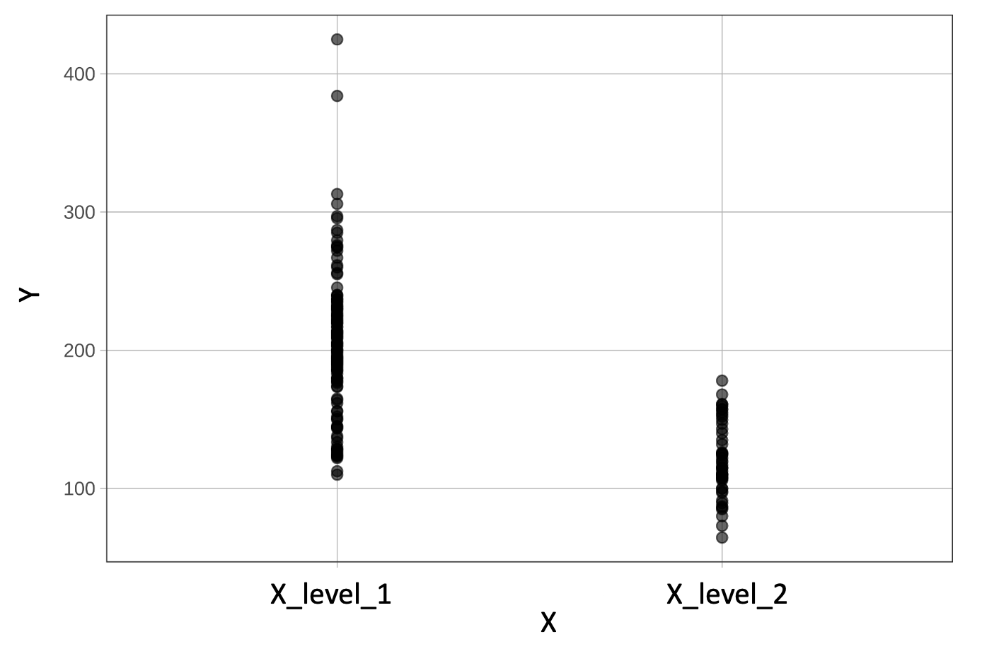  gf_jitter(Y ~ X, data = data_set)  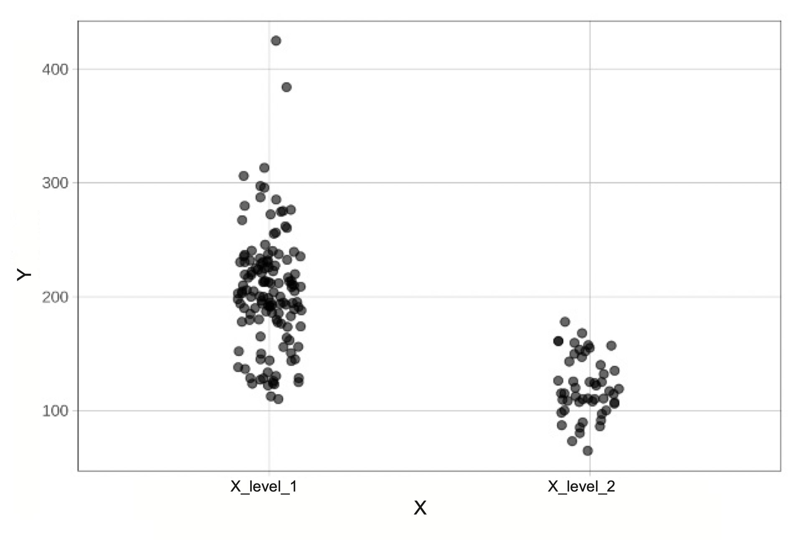  gf_boxplot(Y ~ X, data = data_set)  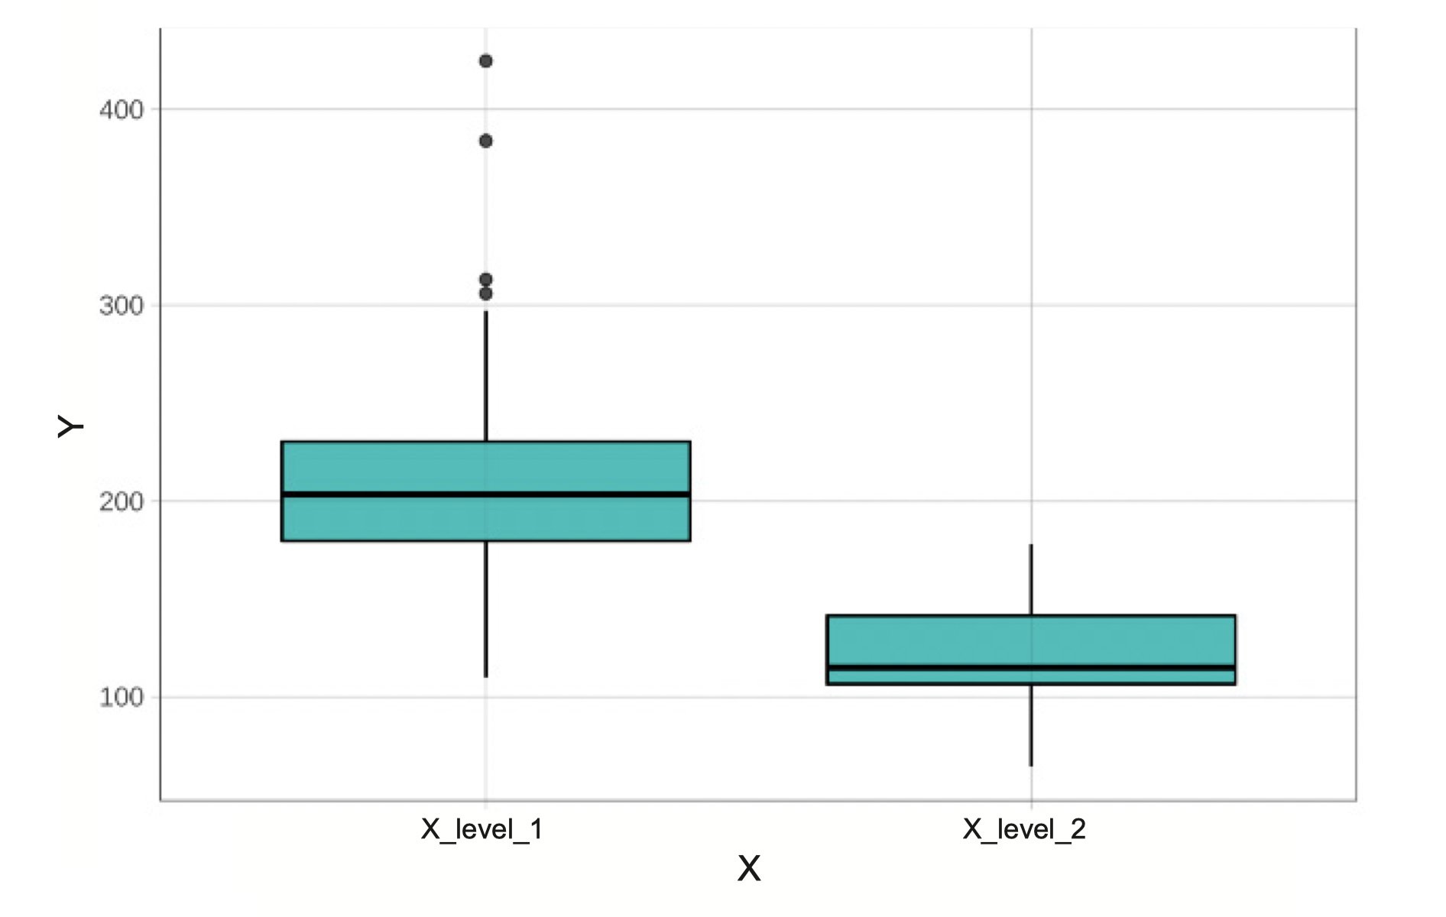  gf_boxplot(Y ~ X, data = data_set, fill = "orange") %>%  gf_jitter(height = 0, alpha = .2, size = 3)  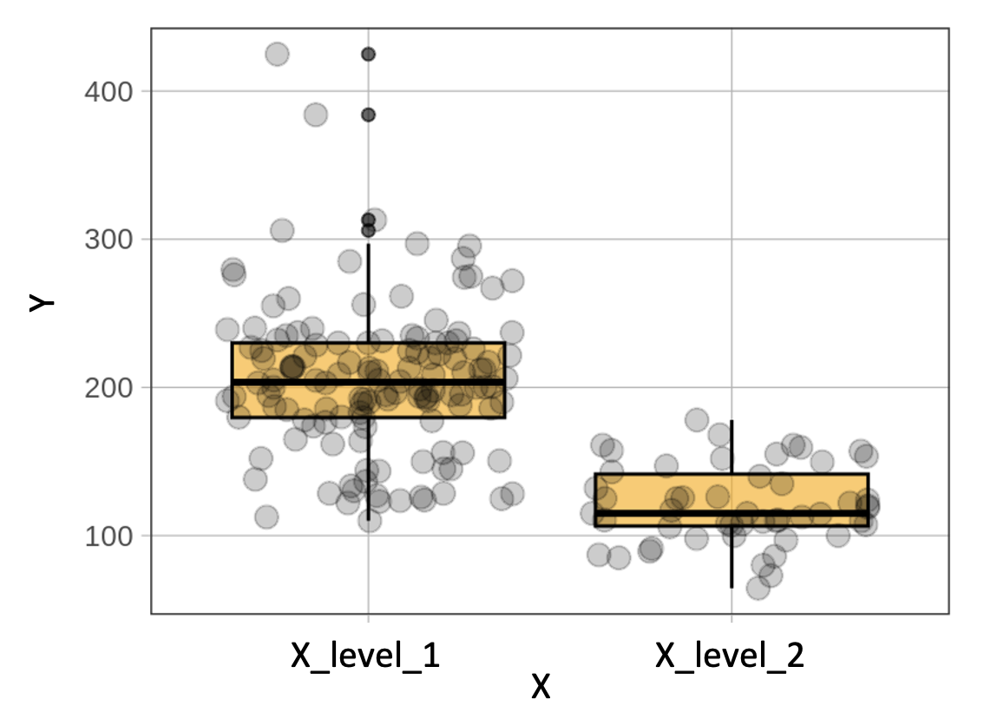 |  | gf_histogram(~ Y, data = data_set) %>%  # change labels  gf_labs(title = "Graph Title",  x = "Y_Name", y = "Frequency")  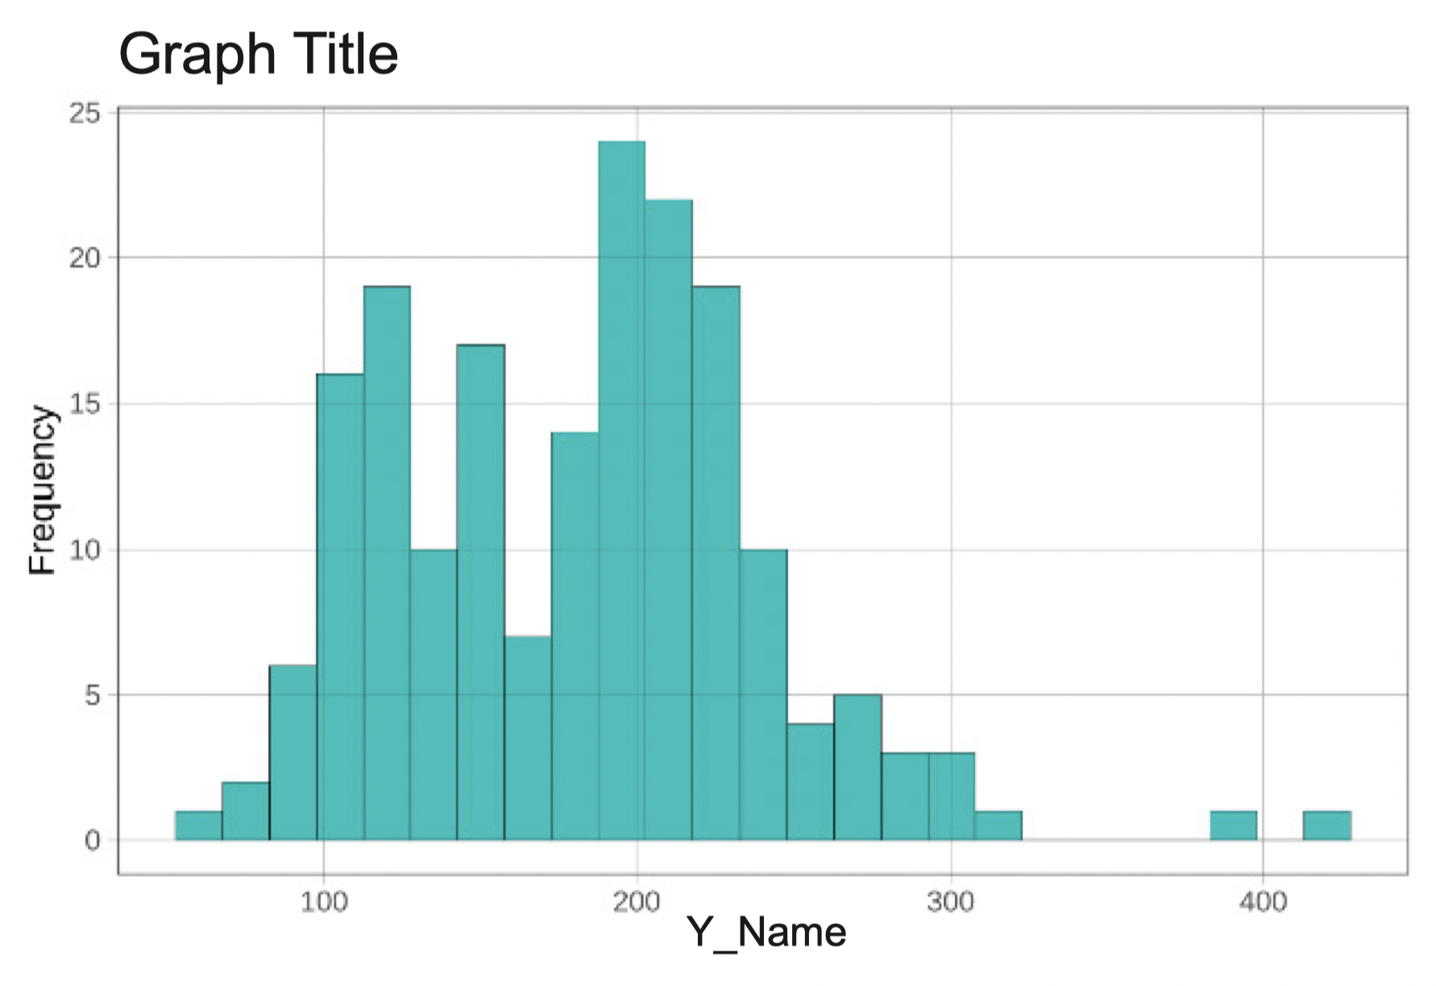  # faceted grid of histograms  gf_histogram(~ Y, data = data_set) %>%  gf_facet_grid(X ~ .)  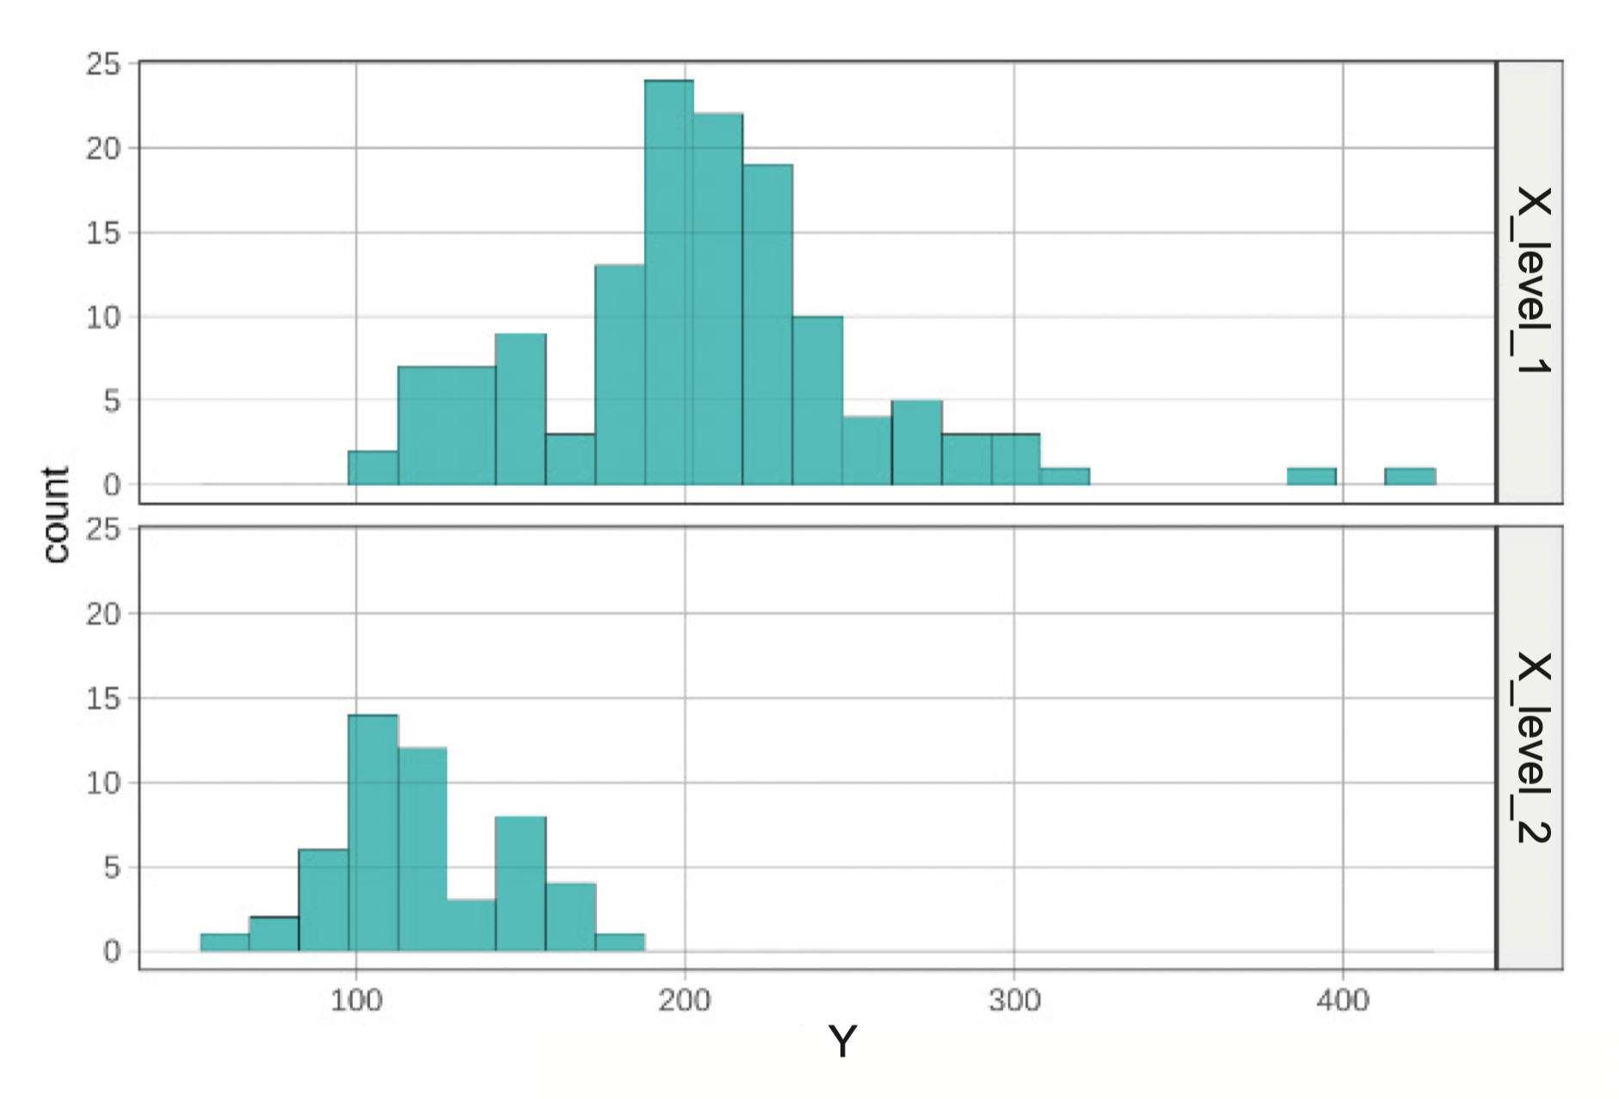  gf_dhistogram(~ Y, data = data_set,  fill = "orange") %>%  gf_density()  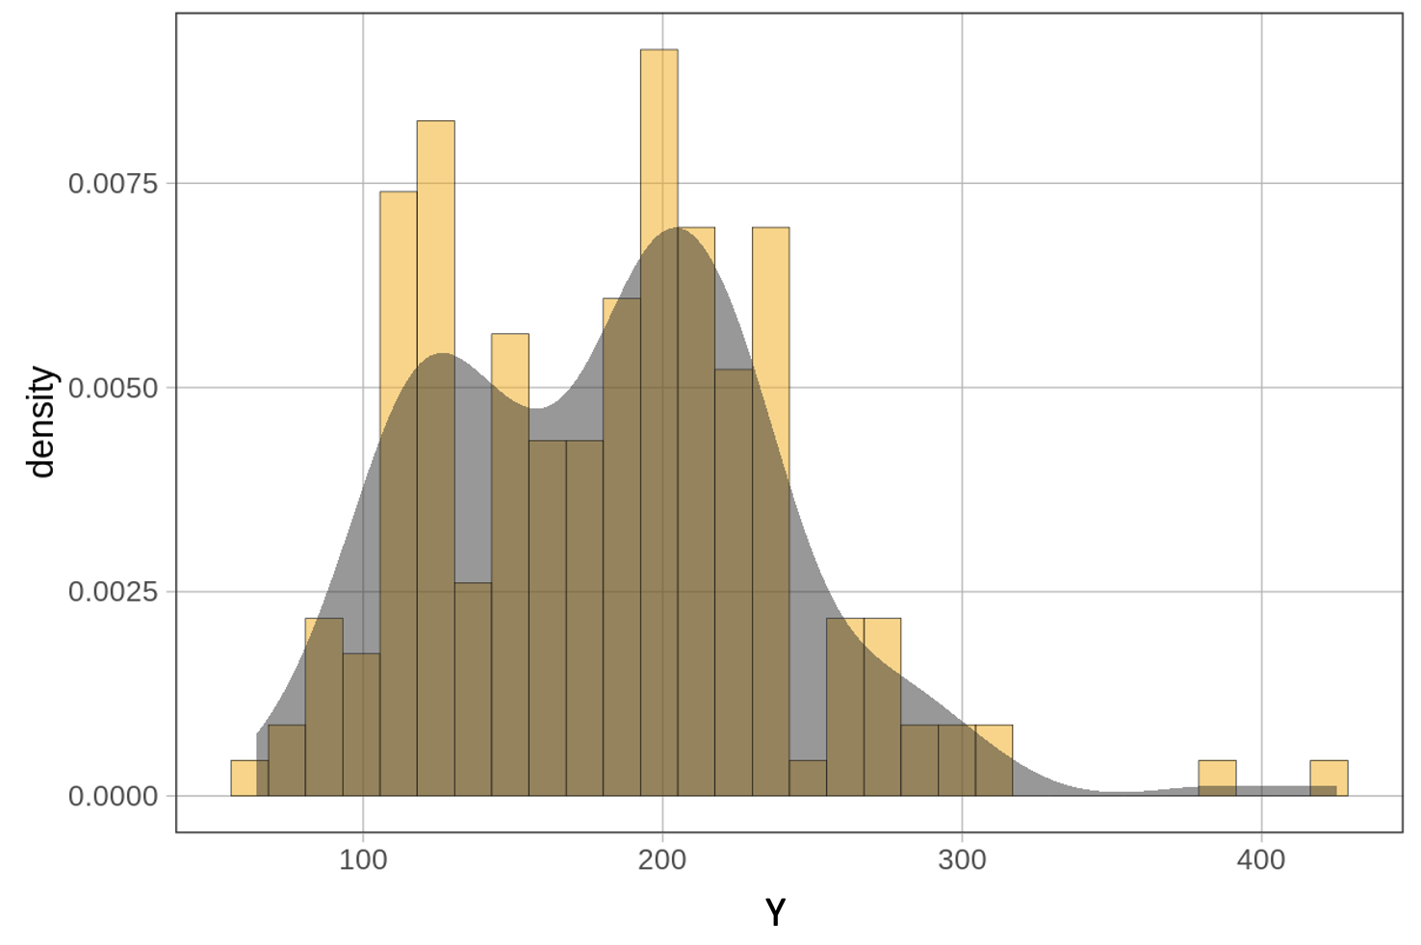  gf_bar( ~ Y, data = data_set)  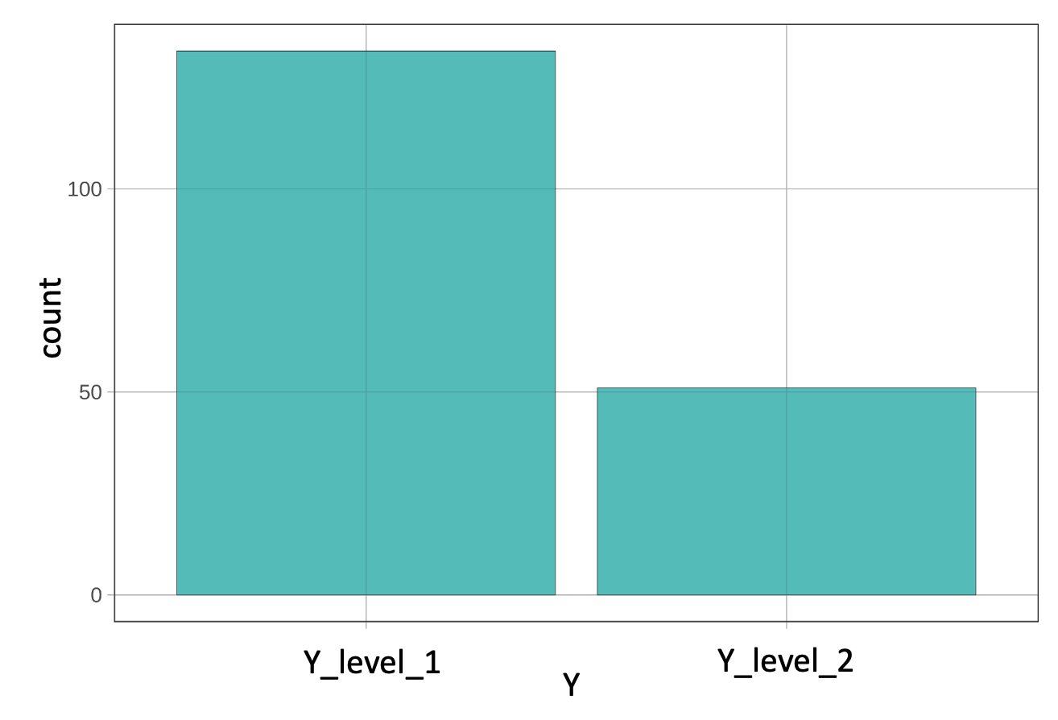 |  |  | # sampling distribution of b1  gf_histogram(~b1, data = sdob1,  fill = ~middle(b1, .95)) %>%  # modify the limits on x- and y-axes  gf_lims(x = c(-12, 12), y = c(0, 70))  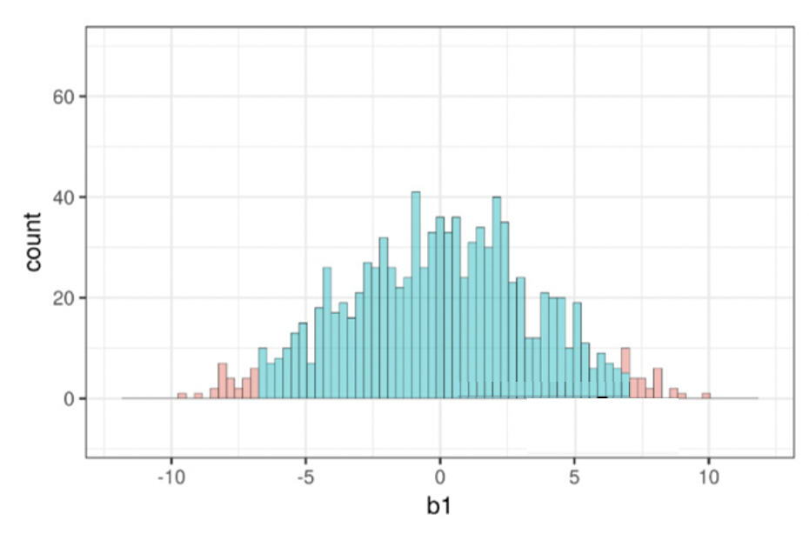  gf_point(Y ~ X, data = data_set) %>%  # add model predictions as red points  gf_point(Y ~ X , shape = 1, size = 3,  color = "firebrick") %>%  # add best fitting model as a red line  gf_model(my_model, color = “red”)  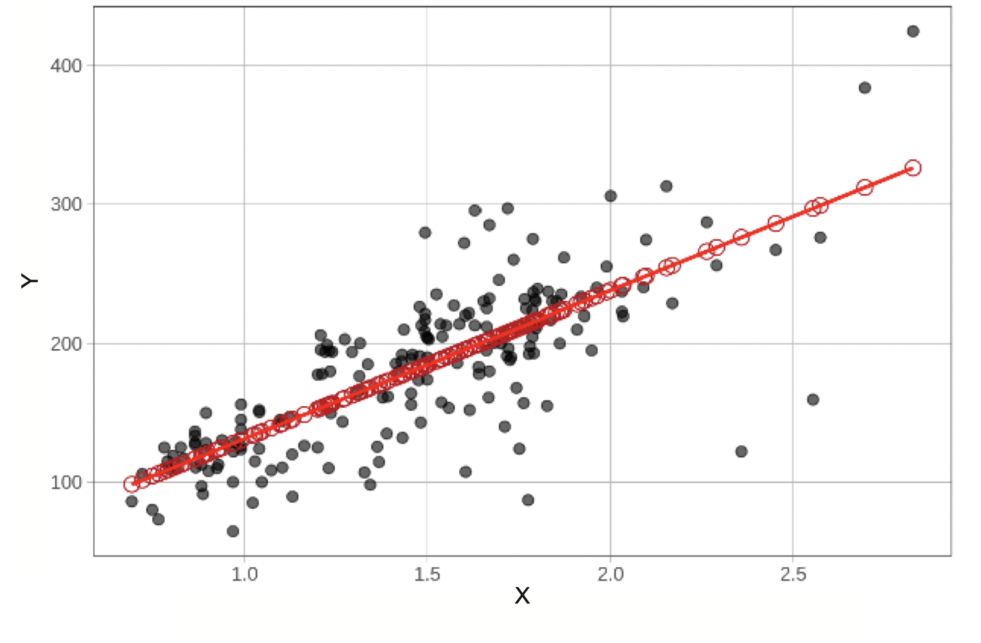  pairwise(my_model, plot = TRUE)  